**Library Management System**

Submitted By

Aman Chopra Department of Computer Science

University Roll No. 12019009022013 UEM, Kolkata

Ananya Das Department of Computer Science

University Roll No. 12019009002004 UEM, Kolkata

Anik Mukherjee Department of Computer Science

University Roll No. 12019009001355 UEM, Kolkata

**Paper Code:** PCCCS481

**Paper Name:** Object Oriented Programming Using Java

Department of Computer Science

UEM, Kolkata



UNIVERSITY OF ENGINEERING & MANAGEMENT, KOLKATA

University Area, Plot No. III – B/5, New Town, Action Area – III, Kolkata – 700 156

**TABLE OF CONTENTS**

**ABSTRACT.................................................................................... 03**

**CHAPTER – 1 : INTRODUCTION**

**1.1 Introduction …………………………………………… 04**

**CHAPTER – 2 : LITERATURE SURVEY**

**2.1 Literature Survey …………………………………….... 05**

**CHAPTER – 3 : PROBLEM STATEMENT**

**3.1 Problem Statement .......................................................... 07**

**3.2 Motivation ........................................................................ 08**

**3.3 Objective …....................................................................... 08**

**CHAPTER – 4: PROPOSED SOLUTION & RESULT ANALYSIS**

**4.1 Methodology Used ............................................................. 09**

**4.2 Database & Tables ............................................................. 11**

**4.3 Results & Reports .............................................................. 16**

**CHAPTER – 5: CONCLUSION & FUTURE SCOPE**

**5.1 Conclusion .......................................................................... 23**

**5.2 Future Scope ...................................................................... 23**

**CHAPTER – 6: BIBLIOGRAPHY .................................................. 24**

**Abstract :-**

Library Management System is a system that maintains the information about the books present in the library, authors of the books, student details, book issued by students, book returned by them, staff members.

This is very difficult to organize manually. Maintenance of all this information manually is a very complex task and risky too. It may be possible that things may go wrong while doing data entry or keep the record update and that can lead to a great loss.

Library Management System is a project which aims in developing a computerized system to maintain all the daily work of library.

This project has many features like :-

1. Admin Login

2. Add New Students

3. Add Books and their details

4. Issuing Books details

5. Book return details etc etc

This project is developed to help library staff members in a best possible way and to help them un maintaining the records of the library more efficiently and effectively.

**Chapter 1**

**INTRODUCTION**

* 1. **Introduction**

Modern generation is very much dependable on the computer and on the use of software for managing all their tasks and work.

This Library Management System project is a Java Swing Application using MySQL as the Database. This can be used by the librarian , here is a Admin login system through which only that person can make a login who has necessary credentials.

It can be used by librarian to manage the library using a computerized system to keep a track record of various transactions like issue of books, return of books, addition of new books, addition of new students etc.

Books and Students maintenance modules are also included in this system which would keep track record of the students using the library and also a detailed description about the books a library contains. With this computerized system there will be no loss of book records or member which generally happens when a non computerized system is used.

All of these modules are able to help librarian to manage the library with more convenience and in a more efficient way as compared to library system which are not computerized.

**Chapter 2**

**LITERARTURE SURVEY**

**2.1 Literature Survey**

Most of the research and writings on library management have focused on academic libraries and only recently has there been more interest in the administration of public libraries. The skill and style of public library managers – the directors, branch managers, and department and service managers who are leading these institutions – strongly affects the culture of a public library.

Library staff looks to these managers to help them navigate through the rapid changes that are occurring in public libraries as these changes in technology, roles, and user expectations strongly alter their daily routines of public service. Contemporary library managers need a wider array of skills and attributes than their earlier and more traditional counterparts and will need to seek continual professional development to remain effective as public libraries transition into the twenty-first century.

These managers will also need to distinguish between management and leadership skills and learn to identify and mentor leaders within their staff who can assist in the transition. This paper is a brief scan of the literature currently available on managing libraries and includes information on academic as well as public libraries due to the above-mentioned lack of public library material. Weiner reviewed the literature extant on leadership in academic libraries and surveyed materials on “recruitment, leadership potential identification, career development, roles and responsibilities, and characteristics and management style”.

Hernon and Rossiter (2006) studied the emotional intelligence concepts that are relevant to university library directors. Their research involved two different activities for gathering information. They analyzed all of the job advertisements for library directors in College & Research Libraries News from 2000 to 2004 and looked for any mention of leadership skills. Then they interviewed university library directors to compare their career experiences with the information taken from the advertisements.

Sager’s (2001) writings on identifying the skills and attributes needed in library administration derive from his work as a library executive recruiter. He has conversed with many library administrators, board members and trustees, search committees, and job candidates and proposes that successful managers need not only the traditional skills that have defined a library manager’s role, but also many newer skills as well. Sager believes that there is “much greater complexity in managing today’s libraries”

The Next Library Leadership: Attributes of Academic and Public library Directors discusses in great detail the leadership qualities and styles, managerial qualities, personal qualities, and knowledge areas that are desirable for a library director in either a public or academic setting. A Delphi study was used to gather data from public library directors via email to identify and rank leadership attributes and the results of their research are defined through narratives as well as in tabular form.

Results from the study helped the authors to rank the most beneficial managerial attributes as the ability to work effectively with library boards and staff and to advocate for library in the community. Desirable personal attributes included integrity, vision, and effective oral, written, and interpersonal communication skills. Directors must also possess knowledge of trends, innovations, and current library best practices and be able to plan effectively for the future.

**Chapter 3**

**PROBLEM STATEMENT**

**3.1 Problem Statement**

In the present generation, where for every work to be done we are dependent on the computers and the software we were still maintaining our library whether in school, colleges, public libraries in a conventional way i.e. maintaining each and every record manually, using pen and paper to maintain the entries of the books issued, students records, books returned, library staff members etc which was becoming very hectic and difficult to maintain such a large database records of everything. That’s why there was a need of a simplified solution from where one can manage all the records of the library much easily and effectively without the loss of any data or a record. Here comes a simplified solution of using a Library Management System software to increase and simplify the work.

**3.2 Motivation**

Libraries are essential in a process of giving citizens access to knowledge. In digital times they are needed more than ever before. In our country, the records of the library are maintained by using pen and paper which causes great loss to environment as cutting down of millions of trees for the sake of making papers is not a sustainable solution to maintain the records. For the sake of our environment, we take this step (Library Management System Software) to reduce the cutting down of trees.

**3.3 Objective**

The aim of this project is to develop a system that can handle and manage the activities involved in a library in an efficient and reliable way. Less managing personnel and easy maintenance of database.

* Develop a system that can replace the manual library managing system.
* Develop a database which stores user details and book details and book details.
* Give reliable search facility for the users
* Administrator or librarian should have logins
* Create an easy to understand user friendly environment
* Attractive user interfaces to navigate through the system for the users.

**Chapter 4**

**PROPOSED SOLUTION & RESULT ANALYSIS**

**4.1 Methodology Used**

This project is made using Java Swing in Eclipse IDE with the database MySQL. With the help of Java Swing technology, the frontend part of the application is made and then we have used the JDBC Driver to connect it with the database that was made using MySQL.

**1. Java Swing :-** Swing is a GUI widget toolkit for Java. It is part of Oracle's Java Foundation Classes – an API for providing a graphical user interface for Java programs. Swing was developed to provide a more sophisticated set of GUI components than the earlier Abstract Window Toolkit.

**2. MySQL Database :-** MySQL is an open-source relational database management system.  A relational database organizes data into one or more data tables in which data types may be related to each other; these relations help structure the data. SQL is a language programmers use to create, modify and extract data from the relational database, as well as control user access to the database.

**3. JDBC Driver :-** JDBC provides an interface which allows you to perform SQL operations independently of the instance of the used database. To use JDBC, you require the database specific implementation of the JDBC driver.

**4. MySQL Connector :-** A jar file is a collection of Java classes (usually a library). ... jar is version 8.0. 12 of the MySQL Connector/J JDBC driver. A JDBC driver is used to connect to a database, in this case to MySQL.

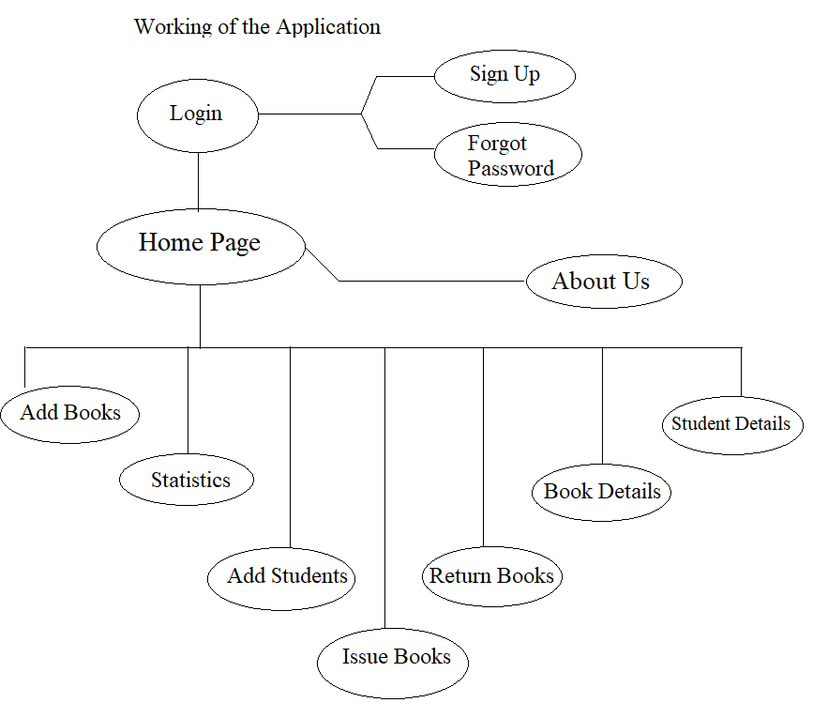

**4.2 Database & Tables**

MySQL is an open-source relational database management system.  A relational database organizes data into one or more data tables in which data types may be related to each other; these relations help structure the data. SQL is a language programmers use to create, modify and extract data from the relational database, as well as control user access to the database.

How to connect Java Application with Database using JDBC Driver?

**Code Snippet :-**

**package** libraryManagementSystem;

**import** java.sql.*;

**public** **class** Conn {

Connection c;

Statement s;

**public** Conn() {

**try** {

Class.*forName*("com.mysql.cj.jdbc.Driver");

c = DriverManager.*getConnection*("jdbc:mysql:///library_management_system","root","root");

s = c.createStatement();

} **catch**(Exception e) {

System.***out***.println(e);

}

}

}

**Tables and their Code Snippets :-**

**1. Account Table :-** In this table, all the credentials of the Admin who are legitimate users of this Library Management System are stored. Using this credentials only they can access this Library Management System application. Thus if anyone wants to access this application their data must be in this account table.

**Snippet :**-

Create table account(username varchar(20), name varchar(25), password varchar(25), sec_q varchar(25), sec_ans varchar(25));

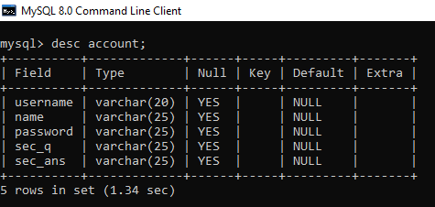

**2. Book Table :-** In this table, all the necessary information related to a particular book like book id, book name, publisher name, edition, price etc are stored so that if the management / students wants a detail bout a specific book, they can easily access it.

**Snippet :**-

Create table book(book_id varchar(10), name varchar(40), isbn varchar(20), publisher varchar(30), edition varchar(10), price varchar(10), pages varchar(10));

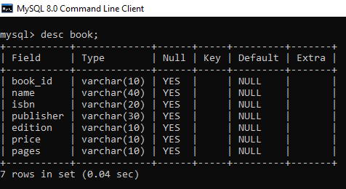

**3. Issue Book Table :-** In this table, all the necessary information related to issuing a book along with that student details like book id, student id, book name, student name, date of issue etc are stored so that the admin can manage all the records of the books issued by the students.

**Snippet :**-

Create table issuebook(book_id varchar(10), student_id varchar(10), bname varchar(40), sname varchar(40), course varchar(20), branch varchar(10), dateOfIssue date);

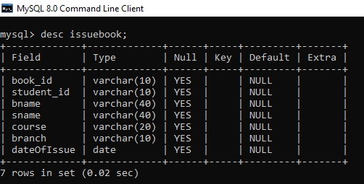

**4. Return Book Table :-** In this table, all the necessary information related to returning a book along with that student details like book id, student id, book name, student name, date of issue etc are stored so that the admin can manage all the records of the books returned by the students.

**Snippet :**-

Create table returnbook(book_id varchar(10), student_id varchar(10), bname varchar(40), sname varchar(40), course varchar(20), branch varchar(10), dateOfIssue varchar(30), dateOfReturn varchar(30));

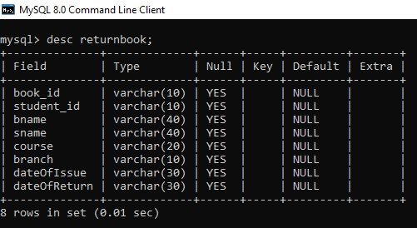

**5. Student Table :-** In this table, all the necessary information related to the student details like student id, name, father name, course, branch etc are stored so that the admin can manage all the records of the students who are using the library resources.

**Snippet :**-

Create table student(student_id varchar(10), name varchar(25), father varchar(25), course varchar(10), branch varchar(10), year varchar(10), semester varchar(10));

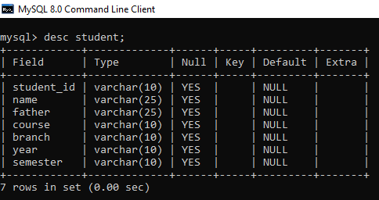

**4.3 Results & Reports**

**1. Login Page**

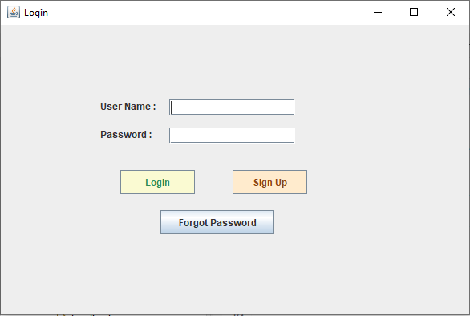

**2. Signup Page**

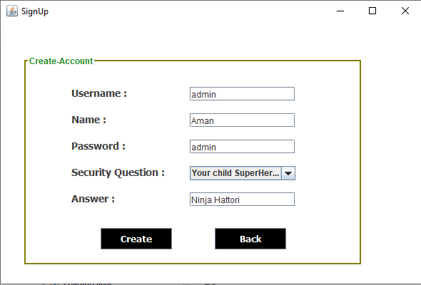

**3. Forgot Password Page**

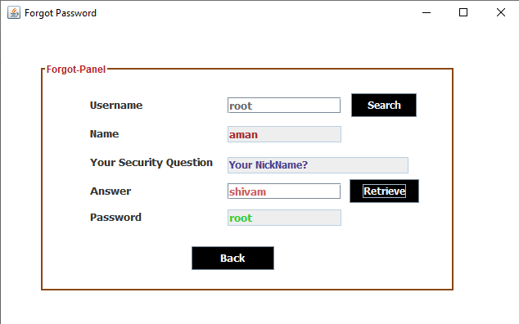

**4. Loading Page**

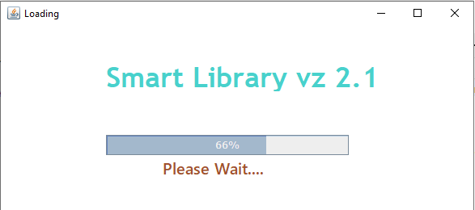

**5. Home Page**

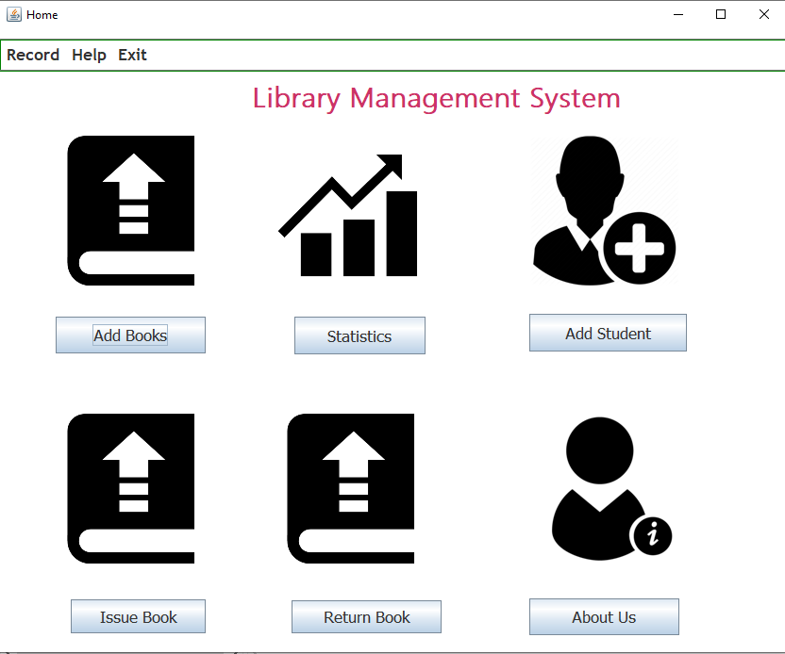

**6. Add Books Page**

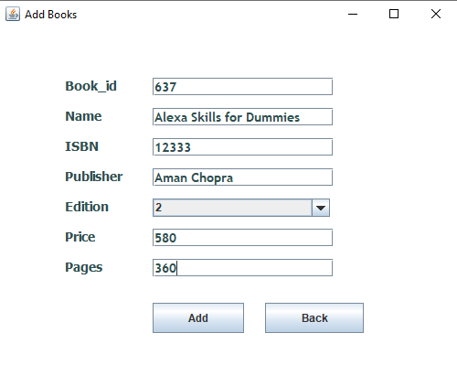

**7. Statistics Page**

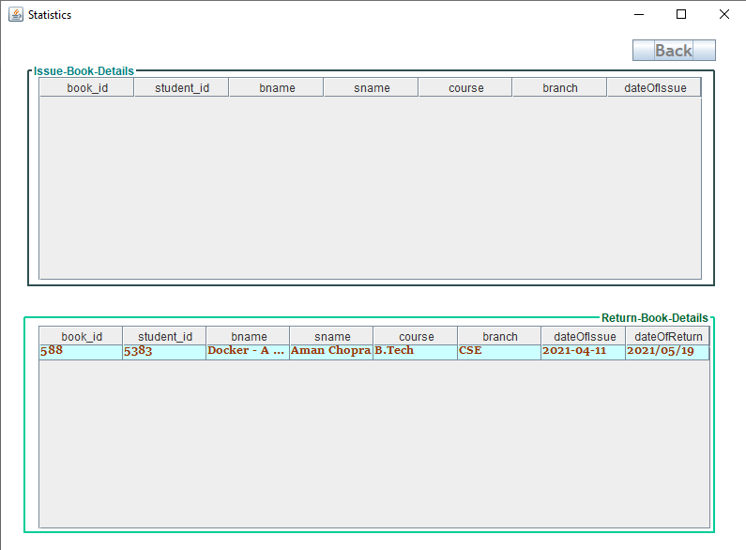

**8. Add Student Page**

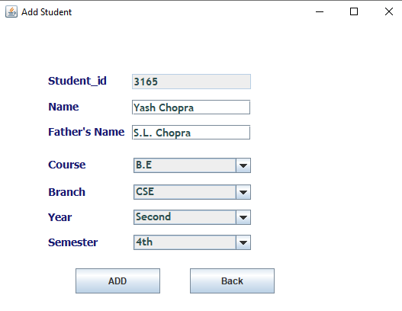

**9. Issue Book Page**

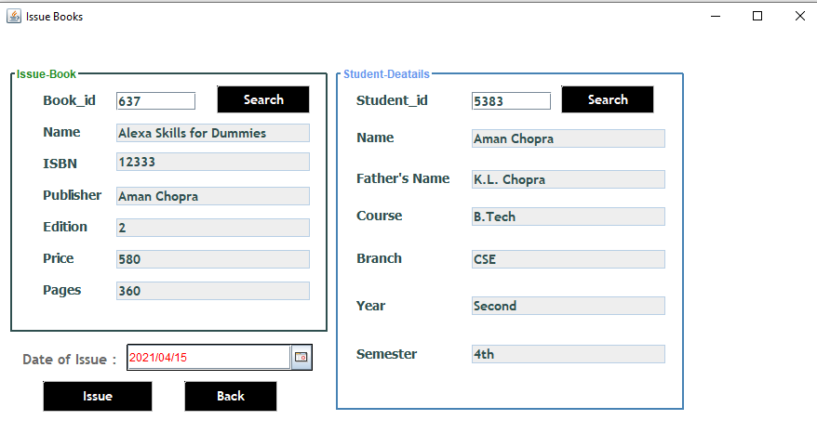

**10. Return Book Page**

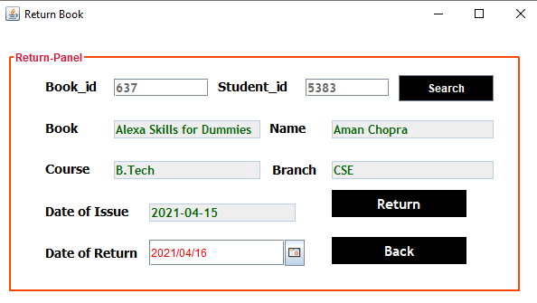

**11. Book Details Page**

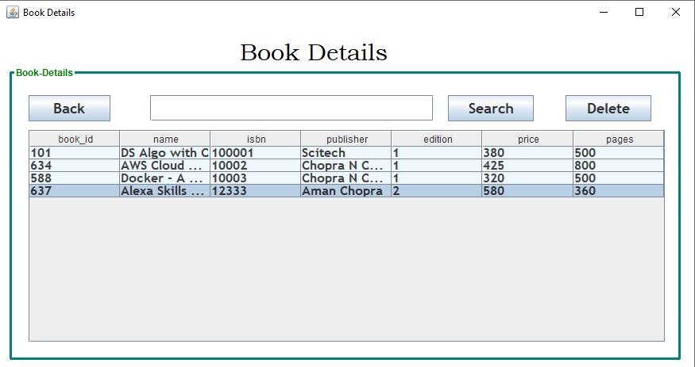

**12. Student Details Page**

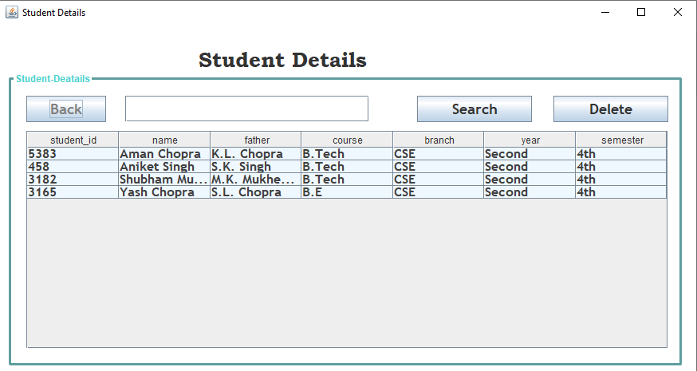

**13. About Us Page**

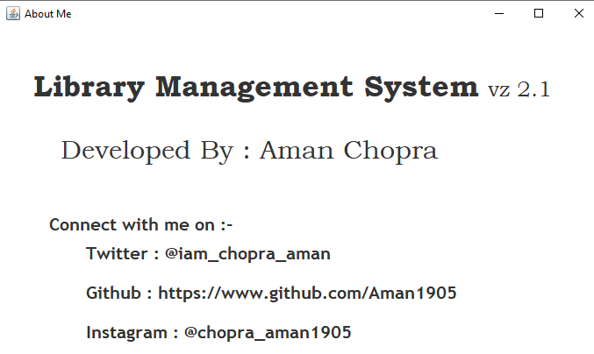

**Chapter 5**

**CONCLUSION & FUTURE SCOPE**

**5.1 Conclusion**

In this Library Management Application we have various features that typically we have to do it manually. It has features like Add Book Details, Add Student, Issue a Book, Return a Book, Statistics Page in which we get info about student issuing a book, Books Details and Students Details like pages. It also stores Student’s information such as name, id, father’s name, batch, semester which will help admin to maintain the records and tracks of all the students regarding their books when issued and returned.

**5.2 Future Scope**

* We can make this as Server based Application
* We can add a Student Interaction Model too
* We can also make this as an Android and IOS application
* We can make this application open for all over the world
* We can also upload some pdfs or notes in this application so that students can access the resources remotely too.

**Chapter 6**

**BIBLIOGRAPHY**

**References :-**

* <https://www.eclipse.org/ide/>
* <https://www.mysql.com/downloads/>
* <https://dev.mysql.com/downloads/connector/j/>
* <https://www.javatpoint.com/java-jdbc>
* <https://www.mysql.com/products/connector/>
* <https://toedter.com/jcalendar/>
* <http://www.java2s.com/Code/Jar/j/Downloadjcalendar14jar.htm>
* <https://hacksmile.com/rs2xml-jar-free-download/>

For complete source code of the Project :-

* <https://github.com/Aman1905/Library-Management-Project-Java-Swing-MySQL>